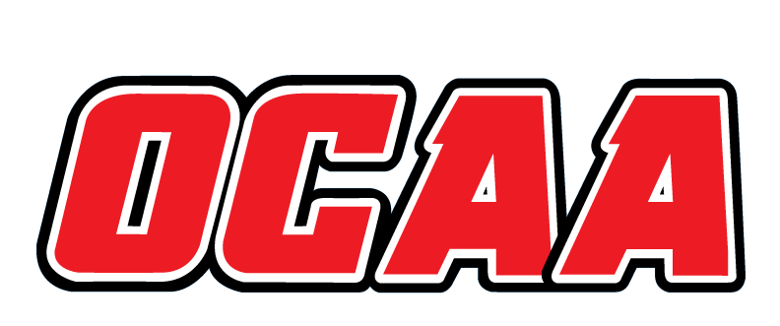
ONTARIO COLLEGES ATHLETIC ASSOCIATION

2019-2020 STANDARDIZED TEAM ROSTER

AS OF: | September 10, 2019

School: | MOHAWK |  | Team: | CROSS COUNTRY
First Name | Last Name | # | POS | Height | Hometown | Year | Name Pronunciation
Josh | Boisvert |  |  | 6’0 | Hamilton – Hagersville | 2 | Bwa – vert
Liam | Bootsma |  |  | 5’8 | Belleville – QCHS | 1
Miranda | Bos |  |  | 5’6 | Wellandport – Smithville | 2 | Bosh
Alex | Evans |  |  | 5’2 | Mississauga – Cawthra Park | 1
Antonio | Fricano |  |  | 5’10 | Ancaster – Bishop Tonnos | 1 | Frick – an – o
Ryan | Herd |  |  | 5’9 | Ancaster - Bishop Tonnos | 1
Madisonne | Hesselink |  |  | 5’7 | Moorefield – Norwell SS | 1 | Hess – ill - ink
Brian | Knechtel |  |  | 6’2 | Beamsville – Beamsville | 1 | Neck – till
Samantha | Lawson |  |  | 5’8 | Seaforth – Central Huron SS | 1
Agatha | Lee |  |  | 5’2 | South Korea | 1
Dexton | Leslie |  |  | 5’11 | Jamaica | 1
Ashley | Lof |  |  | 5’7 | Smithville – Guidos de Bres | 1 | Loff
Navneet | Mann |  |  | 5’2 | Burlington | 1
Vasu | Narula |  |  | 5’8 | India | 4 | Vah – soo Na – rule - a
Carter | Rudge |  |  | 5’5 | Thorold – Denis Morris | 2

Coaching Staff:
Position | Name | Name Pronunciation | Year
Head Coach | Ryan Gagnon | Gan – yawn | 2
Assistant Coach | Hannah Sukkau | Soo - cow | 1

The information collected in this form is used and disclosed by the Ontario Colleges Athletic Association (OCAA) in accordance with the terms The Personal Information Protection Policy. For further information about OCAA collection, use and disclosure of personal information, see our Personal Information Protection Policy at www.ocaa.com.

