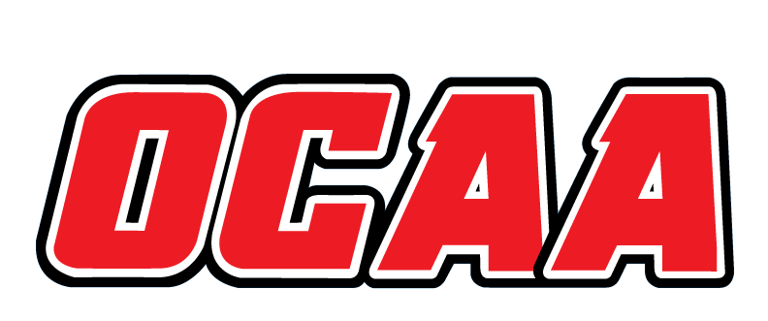
ONTARIO COLLEGES ATHLETIC ASSOCIATION

2021-2022 STANDARDIZED TEAM ROSTER

AS OF: | Jan 31, 2022

School: |  | Centennial |  | Team: |  | Men’s Basketball
First Name |  |  | Last Name |  | # |  | POS | Height | Hometown |  | Secondary School |  |  | Year | Name Pronunciation
Covaun |  |  | Armstrong |  | 5 |  | G | 6’4 | Brampton |  | Holy Cross |  |  | 1 | Co- va -on
Makaile |  |  | Richards |  | 6 |  | G | 6’5 | Brampton |  | White Oaks SS |  |  | 1 | Ma - kai
Malik |  |  | Allen |  | 7 |  | G | 6’2 | Hamilton |  | Sir Winston Churchill |  |  | 1 | Mal - ek
Moustapha |  |  | Youssouf |  | 8 |  | G | 6’2 | Toronto |  | Collège Français |  |  | 1 | You – so - off
Quentin |  |  | Herbert |  | 12 |  | G | 6’3 | Scarborough |  | Birchmount Park |  |  | 3 | Her - bert
Carlos |  |  | Awaogu |  | 22 |  | F | 6’3 | Lagos |  | Kings college Lagos |  |  | 1 | Ah – oh - go
Moses |  |  | Orange |  | 23 |  | G | 6’4 | Scarborough |  | David and Mary Thomson |  |  | 1 | Orange
Declan |  |  | Hannan |  | 33 |  | F | 6’5 | Toronto |  | Rosedale Heights |  |  | 1 | Han - on
Emmanuel |  |  | Osaruyi |  | 34 |  | F | 6’7 | Scarborough |  | St. John Henry Newman |  |  | 1 | O – sa – ur - e
Ryan |  |  | Bongwa |  | 35 |  | F | 6’5 | Cameroon |  | Queensway International |  |  | 1 | Bon – gua

Coaching Staff:
Position | Name | Name Pronunciation | Year
Head Coach | Trevor Challenger | Challenger | 5
Lead Assistant Coach | Ben Sanders | San- ders | 4
Assistant Coach | Chris Stewart | Stew - art | 9
Assistant Coach | Michael Jackman | Jack - man | 3
Assistant Coach | Kareem Rodney | Rod - knee | 1

The information collected in this form is used and disclosed by the Ontario Colleges Athletic Association (OCAA) in accordance with the terms The Personal Information Protection Policy. For further information about OCAA collection, use and disclosure of personal information, see our Personal Information Protection Policy at www.ocaa.com.

