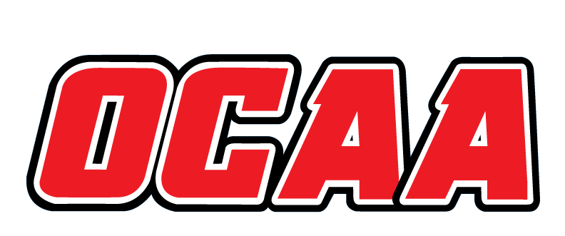
ONTARIO COLLEGES ATHLETIC ASSOCIATION

2021-2022 STANDARDIZED TEAM ROSTER

AS OF: | Jan. 31, 2022

School: |  | Niagara College |  | Team: |  | Men’s Volleyball
First Name |  |  | Last Name |  | # |  | POS | Height | Hometown |  | Secondary School |  |  | Year | Name Pronunciation
Zachary |  |  | Milton |  | 1 |  | Left Side | 6’3 | Port Perry, ON |  | PPHS |  |  | 1 | Zachary Milton
Colin |  |  | Prelaz |  | 2 |  | Left Side | 6’4 | Chatham, ON |  | CKSS |  |  | 2 | Colin Pre-laz
Kole |  |  | Popat |  | 3 |  | Opposite | 6’3 | Port Colbourne, ON |  | Centennial HS |  |  | 1 | Kole Pol-pot
Connor |  |  | Gambell |  | 6 |  | Left Side | 6’1 | Thorold, ON |  | Thorold S.S. |  |  | 1 | Connor Gamble
Ashton |  |  | Nieuwets |  | 8 |  | Middle | 5’11 | St. Catharines, ON |  | Eden HS |  |  | 1 | Ashton New-wets
Carter |  |  | Thurman |  | 11 |  | Setter | 6’2 | Balgonie, SK |  | Greenall HS |  |  | 1 | Carter Thur-man
Tiernan |  |  | Currie |  | 12 |  | Opposite | 6’6 | Carleton Place, ON |  | CPHS |  |  | 1 | Teer-nan Curry
Alec |  |  | Murray |  | 13 |  | Opposite | 6’3 | Mitchell, ON |  | Mitchell District High |  |  | 1 | Alec Murray
Dallas |  |  | Melnick |  | 15 |  | Opposite | 6’1 | Niagara Falls, ON |  | A.N. Myer |  |  | 2 | Mel-nick
Colton |  |  | Borkowski |  | 16 |  | Opposite | 6’5 | Barrie, ON |  | Eastview |  |  | 4 | Col-ton Bor-cow-ski

Coaching Staff:
Position | Name | Name Pronunciation | Year
Head Coach | Tommy Sloan | Tommy Sloan | 4
Assistant Coach | Ben Fillmore | Ben Fill-more | 2
Assistant Coach | Mitch Sawatsky | Mitch Sa-wat-ski | 2
Assistant Coach | Kailey Preece-Flonders | Kailey Preece-Flonders | 2
Assistant Coach | Nick Buckborough | Nick Buck-bur-oh | 1
Athletic Therapist | Kelsie Stunden | Kelsie Stun-den

The information collected in this form is used and disclosed by the Ontario Colleges Athletic Association (OCAA) in accordance with the terms The Personal Information Protection Policy. For further information about OCAA collection, use and disclosure of personal information, see our Personal Information Protection Policy at www.ocaa.com.

