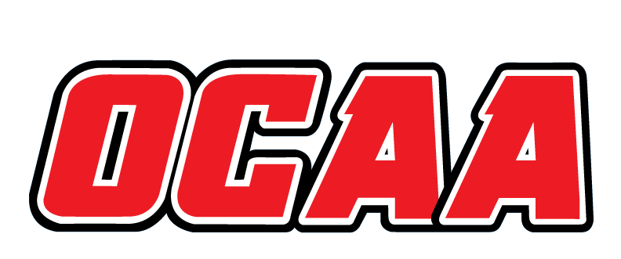
ONTARIO COLLEGES ATHLETIC ASSOCIATION

2021-2022 STANDARDIZED TEAM ROSTER

AS OF: | FEBRUARY 16, 2022

School: |  | BORÉAL VIPÈRES |  | Team: |  | BADMINTON M&W
First Name |  |  | Last Name |  | # | POS | Height | Hometown |  | Secondary School |  |  | Year | Name Pronunciation
Nicholas |  |  | Degagné |  |  |  |  | Elliot Lake |  | Villa Française des jeunes |  |  | 1 | Nih-kuh-la De-gagne
Charles |  |  | De La Riva |  |  |  |  | Sudbury |  | Sacré-Coeur |  |  | 1 | Charlz De La Riva
Frédéric |  |  | Houle |  |  |  |  | Elliot Lake |  | Villa Française des Jeunes |  |  | 1 | Fre-de-ric Houle
Michelle |  |  | Kozlowskyj |  |  |  |  | Sudbury |  | Sacré-Coeur |  |  | 5 | Mih-shel Koz-lows-kee
Kristen |  |  | Vane |  |  |  |  | Timmins |  | Thériault |  |  | 1 | Kris-ten Veyn
Domenic |  |  | St-Aubin |  |  |  |  | Stoney Creek |  | Georges-P-Vanier |  |  | 1 | Doh-mih-nik Saint Au-bin

Coaching Staff:
Position | Name | Name Pronunciation | Year
Head Coach | Julien Bélanger | Ju-lee-en Be-lan-ger | 2018
Assistant Coach | Brittany Bisson | Brih-tuh-nee Bih-son | 2019
Athletic Therapist | Danièle Gervais | Da-neele Juhr-vey | 2014
Atletic Director | Andréa Boyce | An-dree-uh Boyce | 1997

The information collected in this form is used and disclosed by the Ontario Colleges Athletic Association (OCAA) in accordance with the terms The Personal Information Protection Policy. For further information about OCAA collection, use and disclosure of personal information, see our Personal Information Protection Policy at www.ocaa.com.

