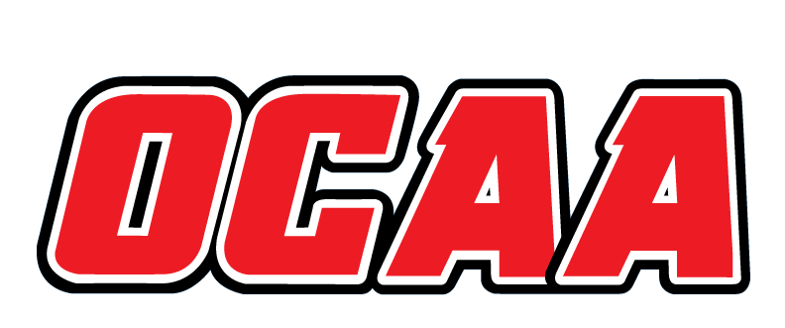
ONTARIO COLLEGES ATHLETIC ASSOCIATION

2021-2022 STANDARDIZED TEAM ROSTER

AS OF: | February 7, 2022

School: |  | Niagara |  | Team: |  | Curling
First Name |  |  | Last Name |  | # |  | POS | Height | Hometown |  | Secondary School |  |  | Year | Name Pronunciation
Men’s Curling
Kyle |  |  | Henry |  |  |  | Vise | 5’11 | Elmira |  | Elmira DSS |  |  | 1 | Kyle Hen-ry
Nathan |  |  | Lohnes |  |  |  | Skip | 6’1 | Halifax |  | Blessed Trinity CS |  |  | 3 | Nathan Lo-h-nes
Adam |  |  | Rolson |  |  |  | Lead | 6’6 | Kitchener |  | Grand River CI |  |  | 2 | Adam Rol-son
Women’s Curling
Amelia |  |  | Bender |  |  |  | Second | 5’5 | Ayer |  | MonSignor Doyle |  |  | 1 | A-me-lia Ben-der
Melissa |  |  | Borowski |  |  |  | Skip | 5’5 | Welland |  | Centennial SS |  |  | 3 | Meliisa Bo-row-ski
Alexa |  |  | Desrochers |  |  |  | Vise | 5’5 | Welland |  | Centennial SS |  |  | 1 | Alexa De-ro-chers
Emma |  |  | Hill |  |  |  | Lead | 5’1 | Dundalk |  | Grey Highlands SS |  |  | 1 | Emma Hill

Coaching Staff:
Position | Name | Name Pronunciation | Year
Head Coach | Bryant Karner | Bry-ent Kar-ner | 1

The information collected in this form is used and disclosed by the Ontario Colleges Athletic Association (OCAA) in accordance with the terms The Personal Information Protection Policy. For further information about OCAA collection, use and disclosure of personal information, see our Personal Information Protection Policy at www.ocaa.com.

