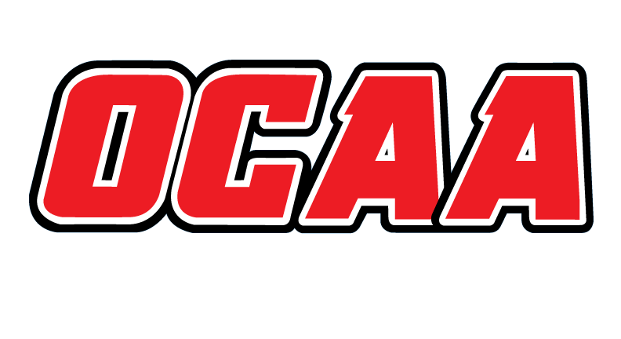ONTARIO COLLEGES ATHLETIC ASSOCIATION

2021-2022 STANDARDIZED TEAM ROSTER

AS OF: | February 15, 2022

School: |  | Sheridan |  | Team: |  | Women’s soccer
First Name |  |  | Last Name |  | # |  | POS | Height | Hometown |  | Secondary School |  |  | Year | Name Pronunciation
Taylor |  |  | Baird |  | 15 |  | D | 5’8 | Ottawa |  | Earl of March |  |  | 3
Brianna |  |  | Tarullo |  | 1 |  | GK | 5’2 | Milton |  | Bishop redding |  |  | 3
Melanie |  |  | Jubenville |  | 17 |  | M | 5’8 | Windsor
Celina |  |  | Barnard |  | 2 |  | M | 5’2 | Brantford |  | Brantford collegiate |  |  | 2
Aneesa |  |  | Gobind |  | 19 |  | D | 5’4 | Cambridge |  | St Marguerite D’youville |  |  | 1
Kiana |  |  | Martin |  | 14 |  | S | 5’3 | Oakville |  | Garth Webb |  |  | 2
Morgan |  |  | Meik |  | 5 |  | D | 5’2 | Brampton |  | Augustine |  |  | 1
Daniella |  |  | Labog |  | 11 |  | D | 5’3 | Miss |  | St Jos |  |  | 1
Kennedy |  |  |  |  | 1/22 |  | GK | 5’6 | Orangeville |  | Orangeville District |  |  | 1
Jessica |  |  | Jagdeo |  | 12 |  | M | 5’4 | Malton |  | Holy Name of Mary |  |  | 1
Nicole |  |  | Hotchkiss |  | 13 |  | D | 5’5 | Oakville |  | Loyola |  |  | 1
Tabatha |  |  | Teixeira |  | 4 |  | D/M | 5’3 | Brampton |  | Augustine |  |  | 4
Sarah Anisha |  |  | Van Wart-Bradbury |  | 1/22 |  | GK | 5’6 | Brampton |  | North Park |  |  | 2
Mikayla |  |  | Longpre |  |  |  | D |  | Brampton
Megan |  |  | Coyle |  |  |  | M |  | Toronto
Shanna |  |  | Gaudreault Greig |  |  |  | M/F | 5’8 | Mississauga |  | St. Famille |  |  | 1

Coaching Staff:
Position | Name | Name Pronunciation | Year
Head coach | Paul Angelini
Assistant coach | Christian McCann
Assistant coach | Nadeka Boothe
Assistant coach | Amrik Hare
Therapist

The information collected in this form is used and disclosed by the Ontario Colleges Athletic Association (OCAA) in accordance with the terms The Personal Information Protection Policy. For further information about OCAA collection, use and disclosure of personal information, see our Personal Information Protection Policy at www.ocaa.com.

